EXP:10
Message Queue IPC
CODE:
#include <stdio.h>
#include <sys/ipc.h>
#include <sys/msg.h>
#include <string.h>
struct msg {
long type;
char text[100];
}
;
int main(void) {
int q = msgget(IPC_PRIVATE, 0600| IPC_CREAT);
struct msg m = {
1, "Hello through message queue"
}, r;
if (q < 0) {
perror("msgget");
return 1;
}
msgsnd(q, & m, sizeof(m.text), 0);
msgrcv(q, & r, sizeof(r.text), 1, 0);
printf("Received: %s\n", r.text);
msgctl(q, IPC_RMID, NULL);
return 0;
}
OUTPUT:
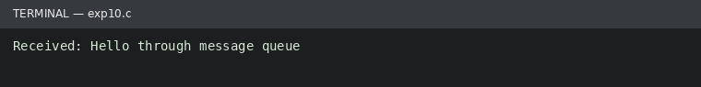
Run status: Ran successfully

